User Manual
ICS 4U1 Summative Project
Environment Simulation
S. Huang, R. Marks, C. Wen

Introduction:

In the 21st century, computer modelling and simulation is becoming a large part of all fields, not just those which are more mathematical (like physics). Even in ecology, computer simulation is a valuable tool. This simple simulation allows the casual ecologist to watch an environment develop over the course of time.

Getting Started:

The program is written in Java, and should be compatible with any modern Java compiler. However, features such as for each loops and Scanner may make it incompatible with older versions of Java, such as Java 1.4.2 (used by the Ready to Program IDE).
When the simulation is paused, the ecosystem editor allows you to change the selected ecosystem's population of an existing species (using the text field), or add a new species (last row). The Save button saves your changes.
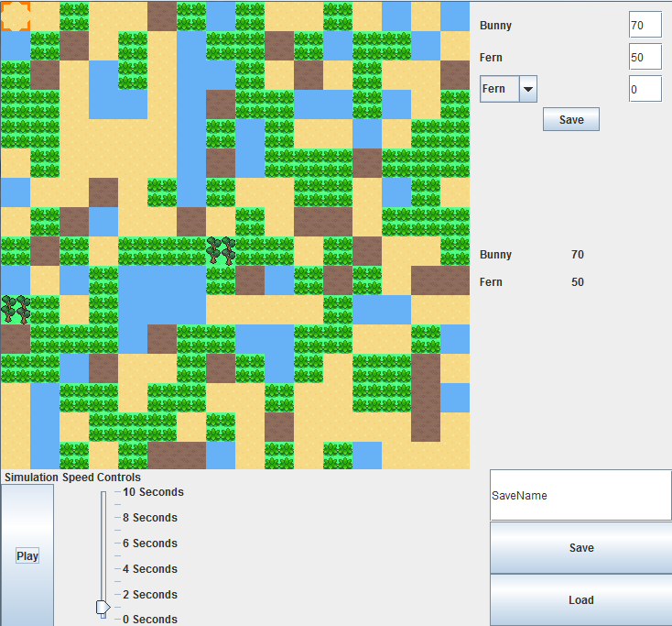
The map of the environment grid. Each block represents one ecosystem.
The selector highlights the current selected ecosystem.
The play/pause button allows you to start and stop the simulation.
Slider allows you to adjust how often the simulation advances.
To save the simulation to a file, type the file name in the text field, and press save. To load from an existing .grid file, type the filename in the text field and press Load.
The global manifest shows the total population of each species in the entire simulation.

